**East West University**

**Course title: Data Communications**

**Course code: CSE350**

**Summer 2024**

**Section: 2**

**Mini project**

**Submitted To:**

**Md. Khalid Mahbub Khan**

Lecturer

Department of Computer Science and Engineering East West University, Dhaka

**Submitted By:**

**Dilruba Akter**

**ID: 2021-3-60-077**

Department of Computer Science and Engineering East West University, Dhaka

**Table of Contents**

1. Introduction 3

2. Tools 3

3. Implementations 3

4. Physical Design 3

5. Project tasks description 4

5.1. Network 4

5.2. Connectivity between all the hosts 4

6. Limitations 5

7. Conclusion 5

8. Codes 5

\

1. **Introduction:**

This is a mini project on a large number of computers, with a complex network infrastructure. This complex network infrastructure is switching/routing mechanisms are in practice. Full network has covered its six computers with four routers.

1. **Tools:** 
   * 1. Routers (PT-Router)
     2. Switches (2960)
     3. Other devices- PC
     4. Connectors- straight through (Router to Switch and Switch to PC), crossover (Router to Router), serial DCE

1. **Implementations:**

In this project, I have used Cisco Packet Tracer software (V-8.2.2). Here I have implanted:

* + 1. Established a full network using four routers.
    2. Network addresses and Default Gateway addresses were given from Class A.

1. 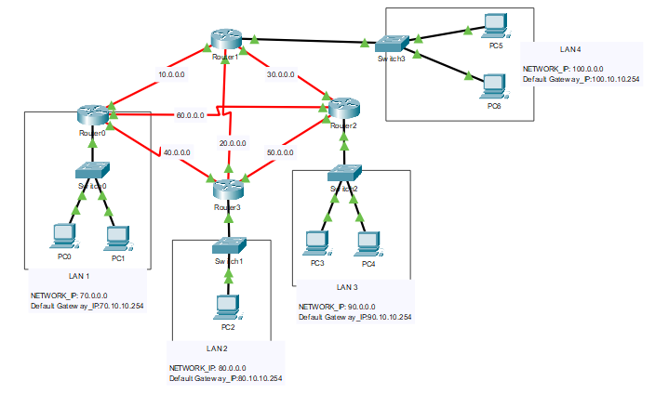P**hysical Design:**

Figure 1: physical diagram of networks

1. **Project tasks description:** 
   1. **Network**:

In this project, there is total 8 networks. I have used all the IP addresses in those networks from class A. LAN-1, 2, 3, and 4 network has class-“A” IP address. Also the router to router networks have class- “A” IP address. The number of networks is fixed in this project.

* 1. **Connectivity between all the hosts**:

After configuring all routers, switches, host, I have tested the whole network by sending simple PDUs from one host to another host. The result is perfect. Every PDUs successfully reached to destination from different networks. So connectivity between all the hosts are perfectly established.

PING operation PC0 from Router0 and PC4 from Router1 is shown. The given designed PC4 is actually my PC5.

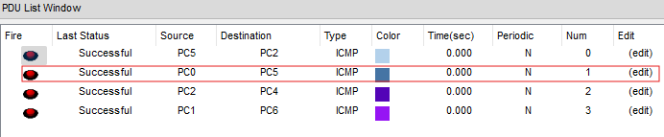

Figure 2: some examples of successful connections between hosts of different networks

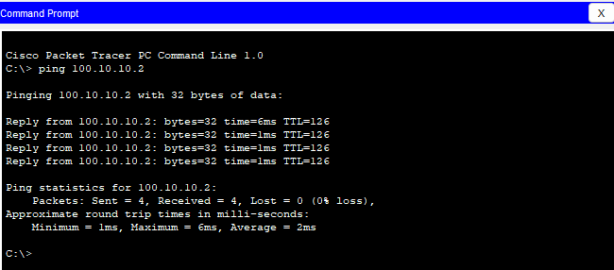

Figure 3: examples of successful connections between PC0 from Router0 and PC4 from Router1

1. **Limitations:**

In this project, all the tasks are completed successfully. Here all the hosts can communicated with each other. I have used small amount of hosts in each networks to give the project. Small amount of hosts could be a limitation.

1. **Conclusion:**

Despite the fact that I encountered some difficulties, I was able to implement my plan in accordance with the project description in the end. This mini project is a reflection of our gained knowledge from Data Communications course. In this project, we had to use the knowledge of different type of classes of IP address, networks different type of protocol and so on.

1. **Codes:**

To configure the router I had to use many lines of code in routers’ CLI.

**8.1. Configure the ports of routers:**

**LAN 1:**

interface fa0/0

ip address 70.10.10.254 255.0.0.0

no shut

do wr

exit

interface se2/0

ip address 10.0.0.1 255.0.0.0

clock rate 64000

no shut

do wr

exit

interface se3/0

ip address 40.0.0.1 255.0.0.0

no shut

do wr

exit

interface se7/0

ip address 60.0.0.1 255.0.0.0

clock rate 64000

no shut

do wr

exit

**LAN 2:**

interface fa0/0

ip address 80.10.10.254 255.0.0.0

no shut

do wr

exit

interface se2/0

ip address 50.0.0.2 255.0.0.0

no shut

do wr

exit

interface se3/0

ip address 40.0.0.2 255.0.0.0

clock rate 64000

no shut

do wr

exit

interface se7/0

ip address 20.0.0.2 255.0.0.0

no shut

do wr

exit

**LAN 3:**

interface fa0/0

ip address 90.10.10.254 255.0.0.0

no shut

do wr

exit

interface se2/0

ip address 30.0.0.2 255.0.0.0

no shut

do wr

exit

interface se3/0

ip address 50.0.0.1 255.0.0.0

clock rate 64000

no shut

do wr

exit

interface se7/0

ip address 60.0.0.2 255.0.0.0

no shut

do wr

exit

**LAN 4:**

interface fa0/0

ip address 100.10.10.254 255.0.0.0

no shut

do wr

exit

interface se2/0

ip address 30.0.0.2 255.0.0.0

no shut

do wr

exit

interface se3/0

ip address 50.0.0.1 255.0.0.0

clock rate 64000

no shut

do wr

exit

interface se7/0

ip address 60.0.0.2 255.0.0.0

no shut

do wr

exit

**8.2. Routing table to the routers dynamically (OSPF)**

router ospf 1

network 10.0.0.0 0.255.255.255 area 1

network 60.0.0.0 0.255.255.255 area 1

network 40.0.0.0 0.255.255.255 area 1

network 70.0.0.0 0.255.255.255 area 1

exit

router ospf 2

network 10.0.0.0 0.255.255.255 area 1

network 20.0.0.0 0.255.255.255 area 1

network 30.0.0.0 0.255.255.255 area 1

network 100.0.0.0 0.255.255.255 area 1

exit

router ospf 3

network 60.0.0.0 0.255.255.255 area 1

network 50.0.0.0 0.255.255.255 area 1

network 30.0.0.0 0.255.255.255 area 1

network 90.0.0.0 0.255.255.255 area 1

exit

router ospf 4

network 20.0.0.0 0.255.255.255 area 1

network 50.0.0.0 0.255.255.255 area 1

network 40.0.0.0 0.255.255.255 area 1

network 80.0.0.0 0.255.255.255 area 1

exit